STEP BY STEP PROCESS :

Step 1: AWS instances CREATION

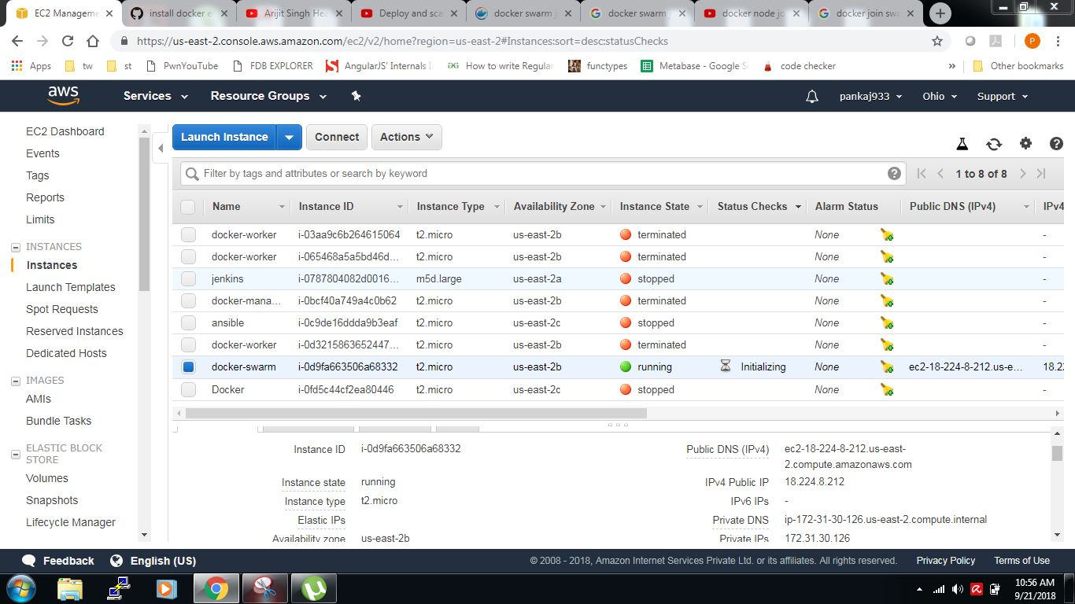

Step 2: connect instance via PUTTY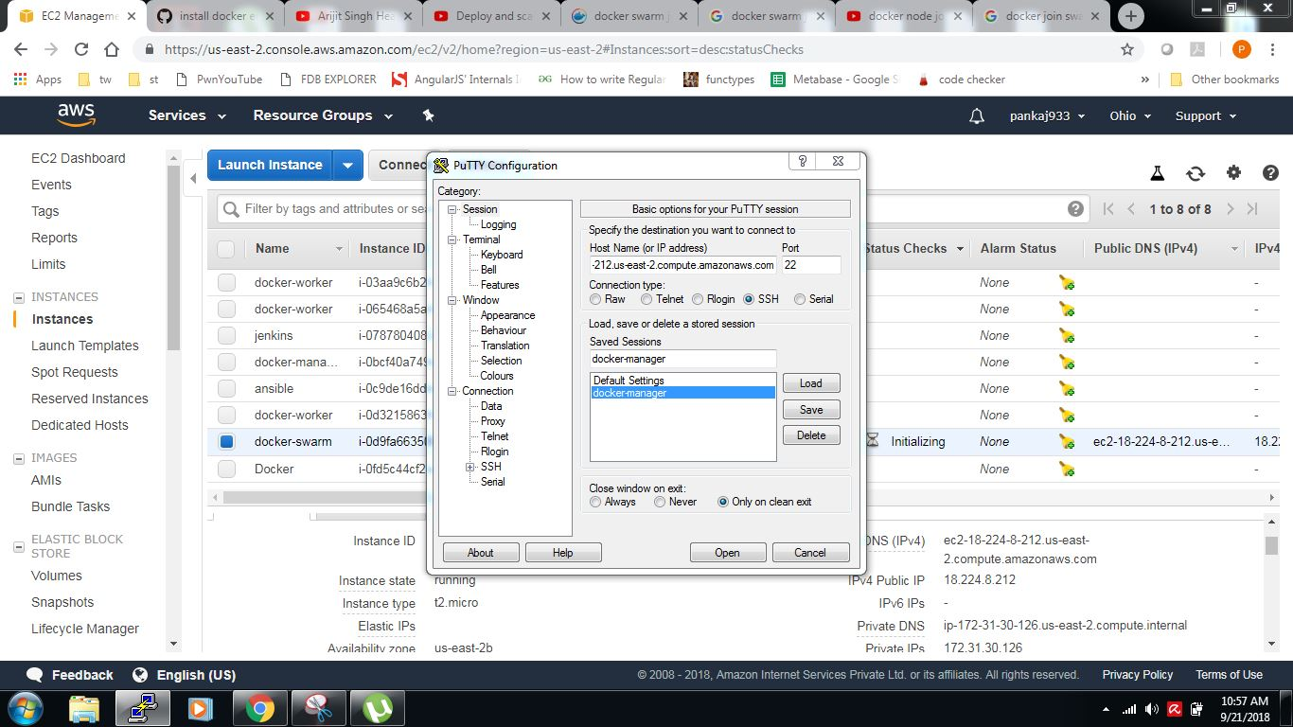

Step 3: Installing Docker on EC2 instance

sudo apt update

sudo apt install apt-transport-https ca-certificates curl software-properties-common

curl -fsSL https://download.docker.com/linux/ubuntu/gpg | sudo apt-key add –

sudo add-apt-repository "deb [arch=amd64] https://download.docker.com/linux/ubuntu bionic stable"

sudo apt update

apt-cache policy docker-ce

sudo apt install docker-ce

sudo systemctl status docker

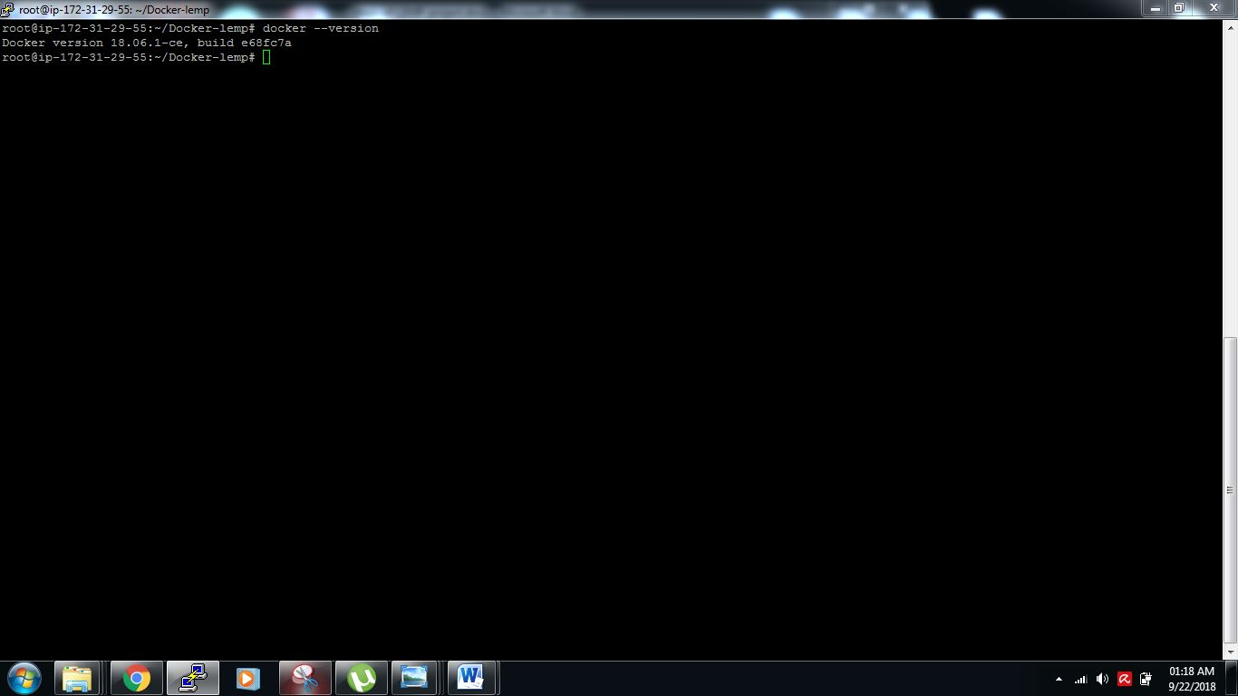

**Step 4: Project directory**

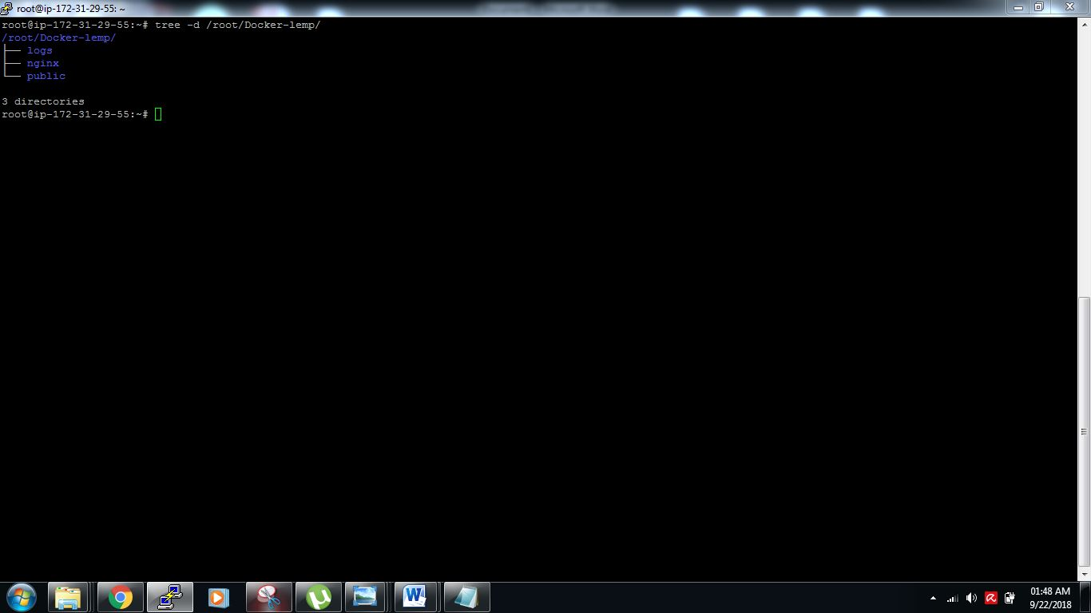

**Step 5: Docker-compose.yml**

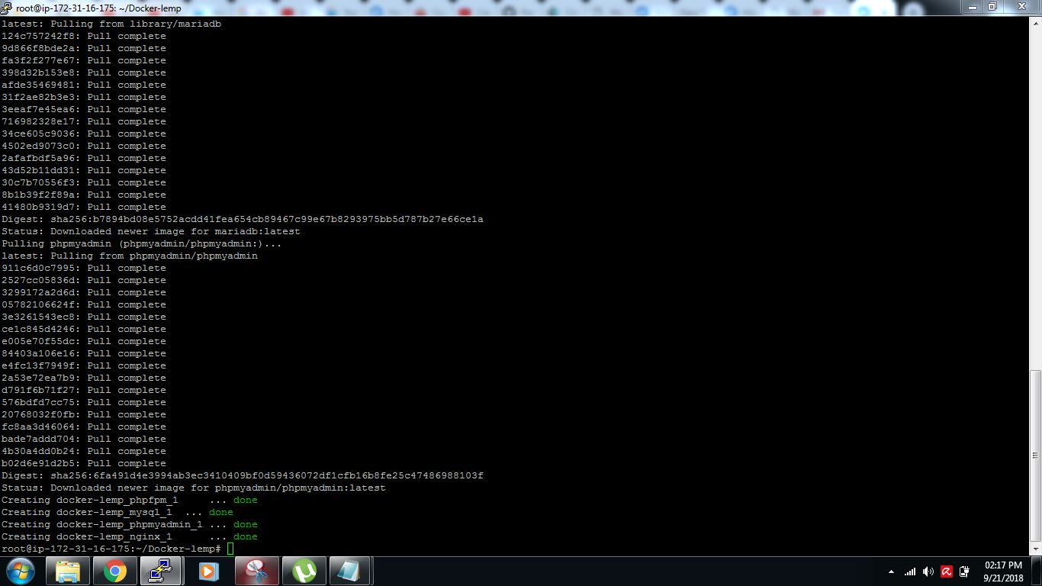

**Step 5: wrote docker compose file**

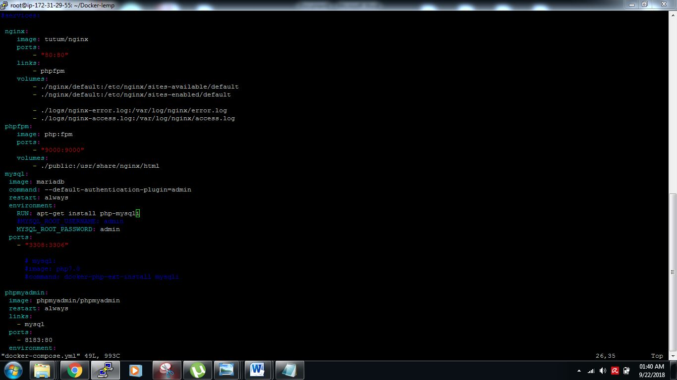

**Step 6: Nginx configuration file (default)**

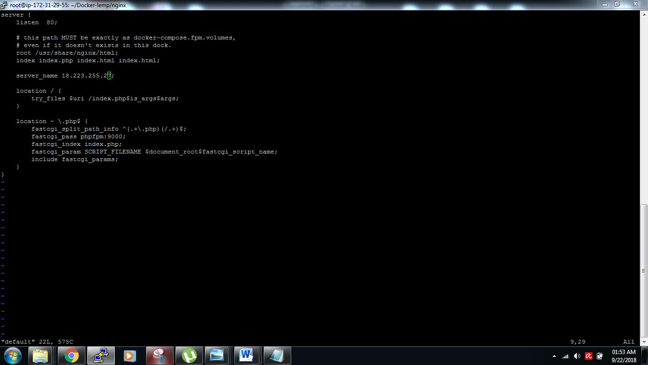

**Step 7: file with php code connectivity with mysql database**

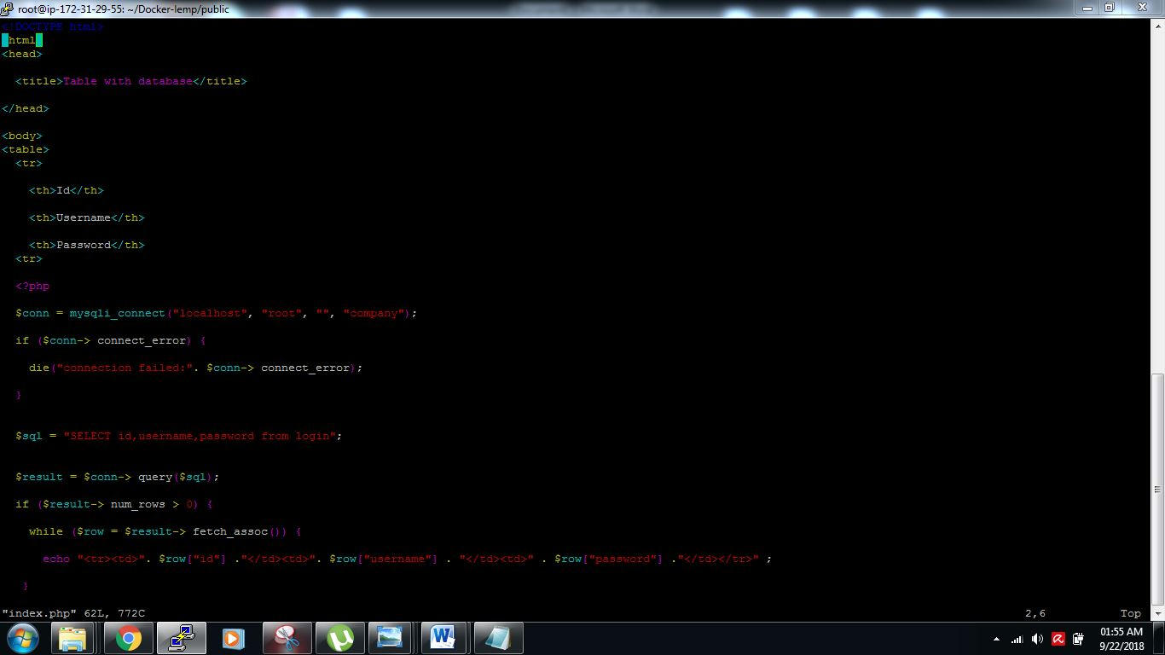

**Step 8: command docker-compose up –d**

**Output:**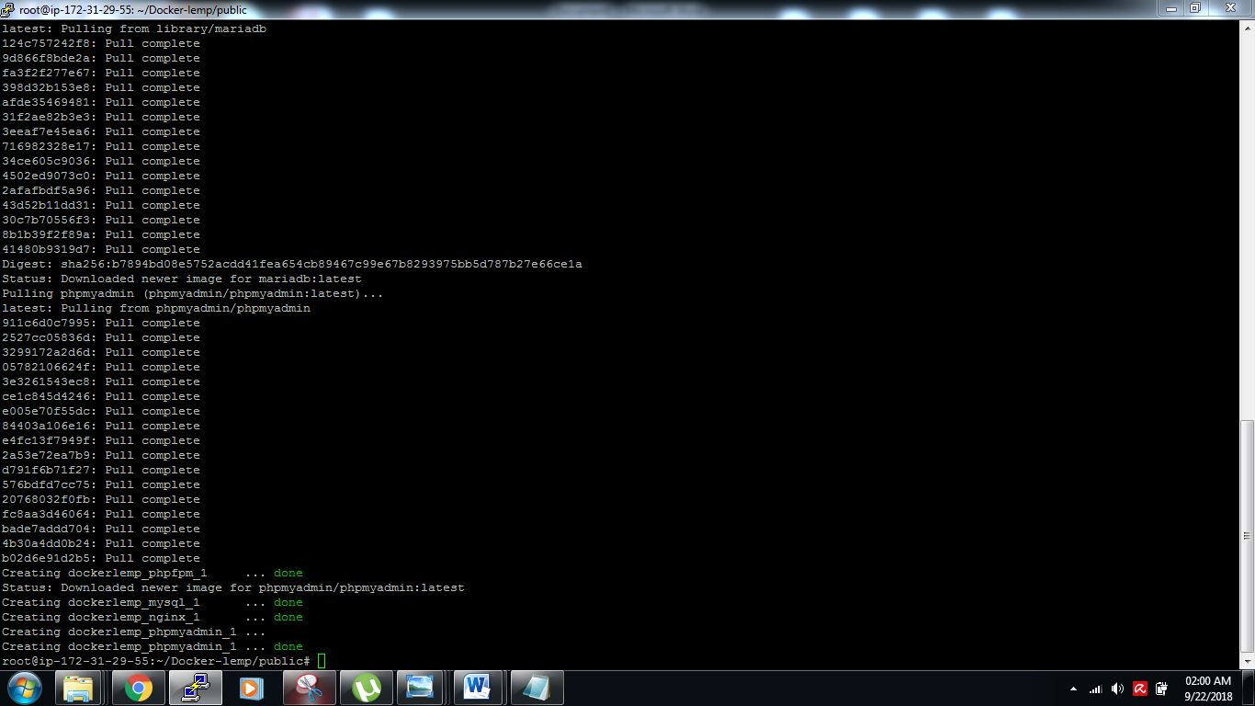

**Step 9: database phpmyadmin**

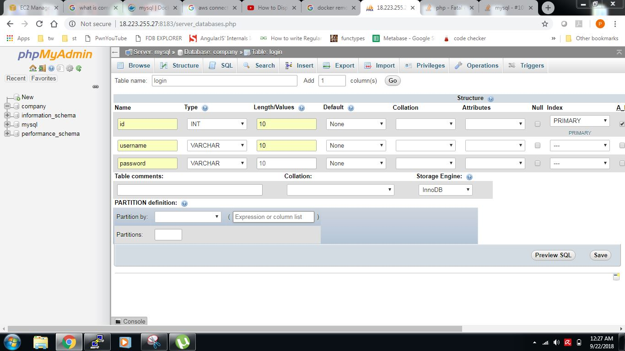

**Step 10: Records print**

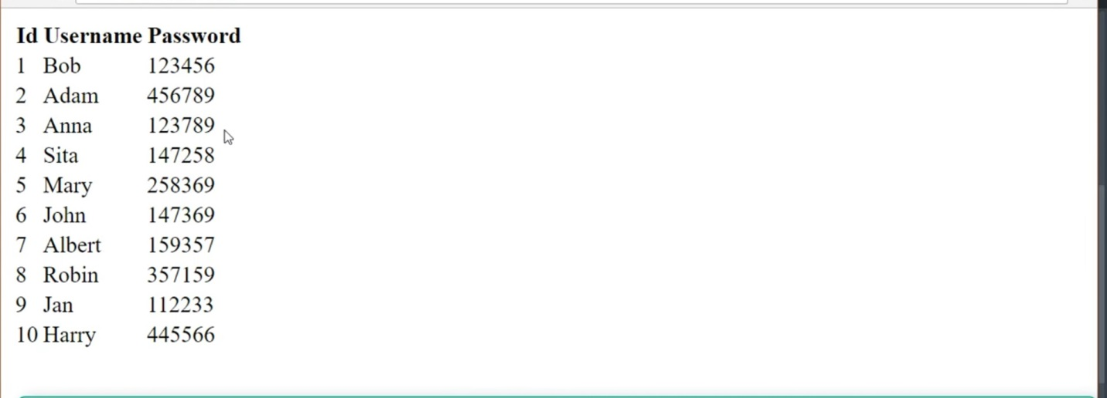

**Step 11: creating swarm-manager or leader and attach him workers**

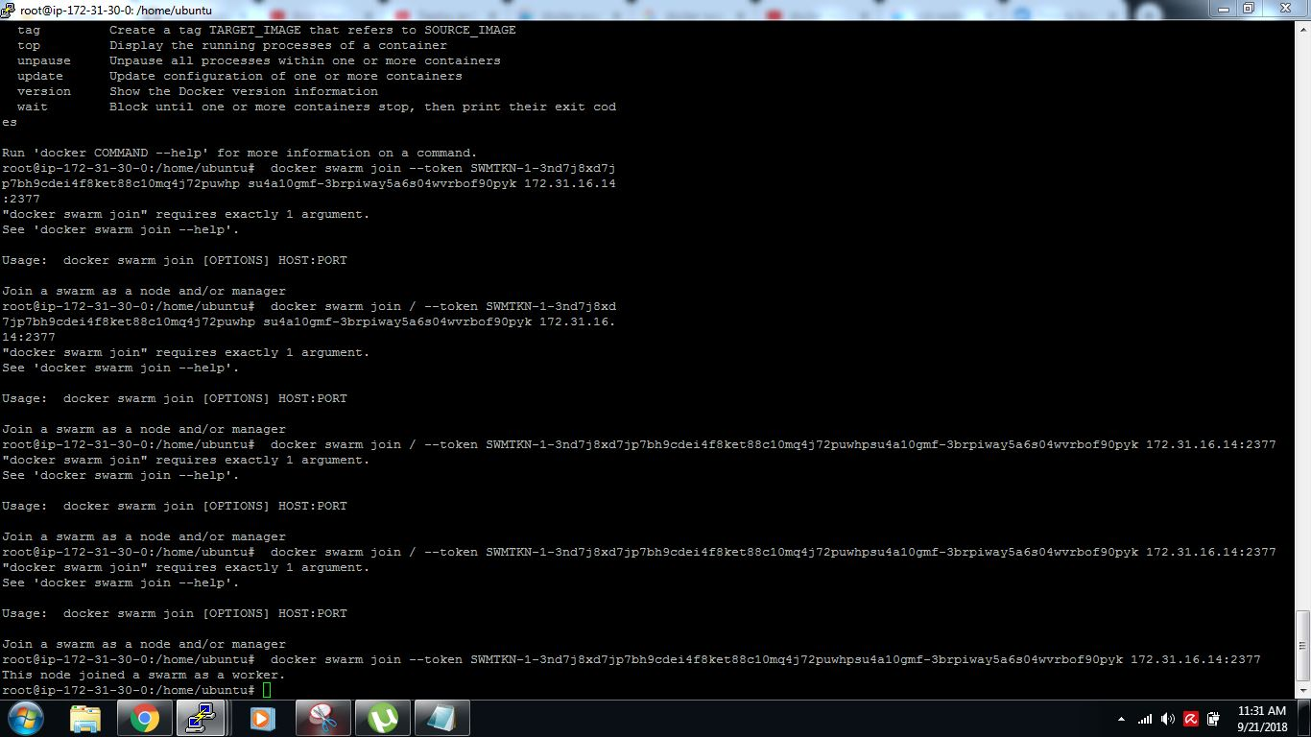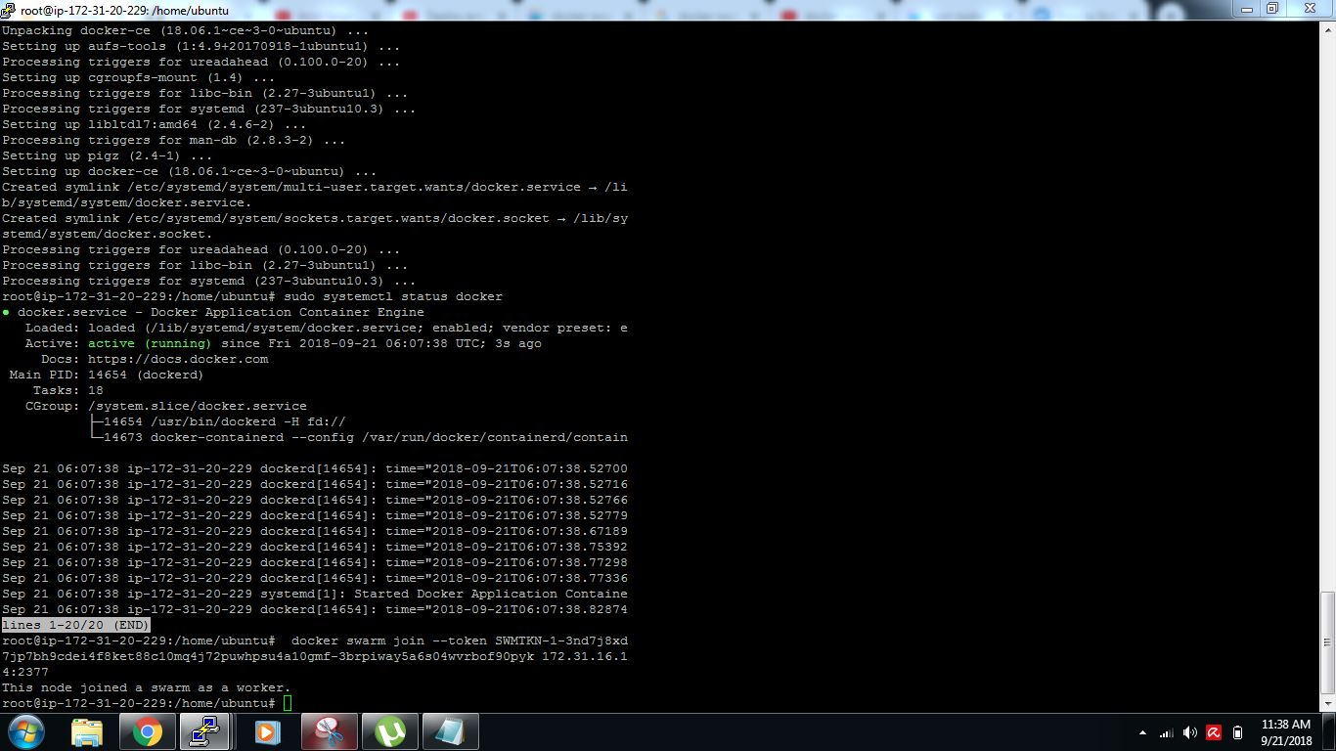

**Step 12: swarm token by which all node connected to each other**

**:: docker swarm join --token SWMTKN-1-3nd7j8xd7jp7bh9cdei4f8ket88c10mq4j72puwhpsu4a10gmf-3brpiway5a6s04wvrbof90pyk 172.31.16.14:2377**

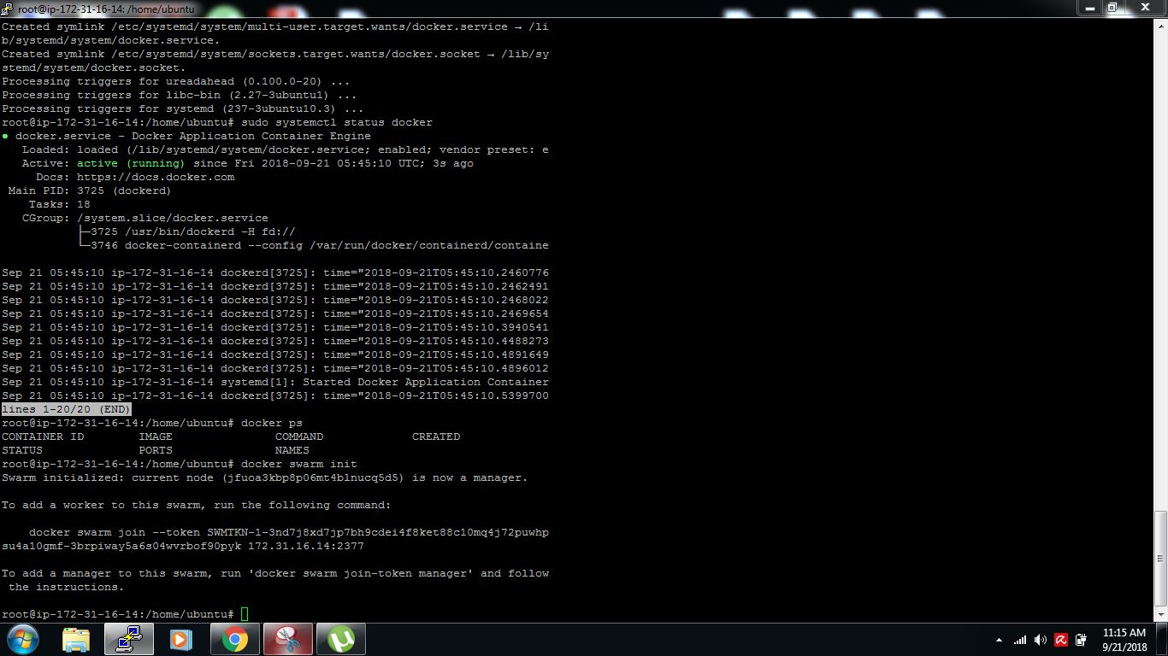

**Step 13: Node list of Docker swarm**

**Command: docker node ls**

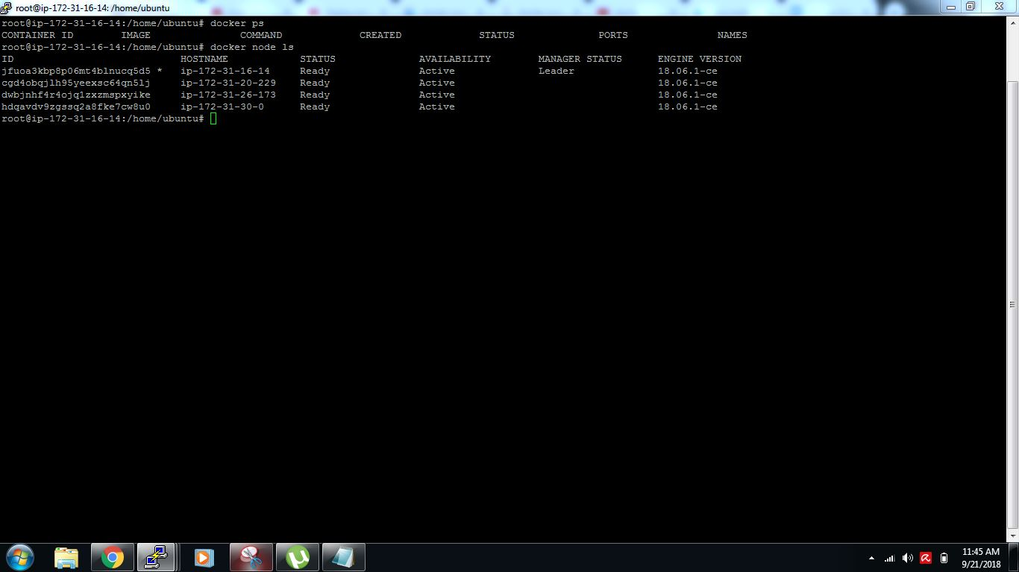

**Step 14: scaling up and scalling down**

**Command: docker service scale webservice=10**

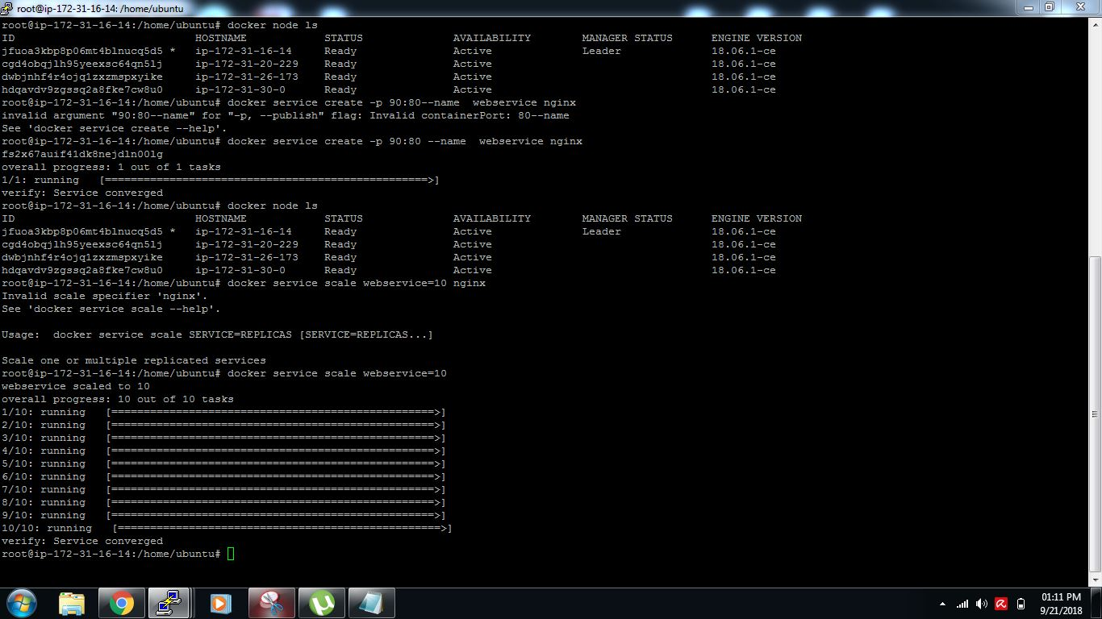

**Step 15: Scale down docker swarm**

**Command: docker service scale webservice=2**

